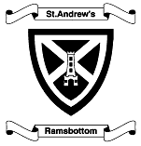
ST ANDREW’S CE PRIMARY SCHOOL

NUTTALL LANE RAMSBOTTOM BURY LANCS BL0 9JD

Headteacher: Mr D Marsh B.A. Hons NPQH

Deputy Headteacher: Mr J Brown B.A. Hons

Telephone: 01706 822649

Friday 6th January 2023

Dear Parents/Carers,

This week your child should have brought home three “SATs Buster – 10 minute tests” books, for Maths, Grammar & Punctuation and Reading. These books contain mini SATs-style tests which your child should complete each week, to be handed in on the relevant day along with their spelling homework (Thursday in Y5/6 and Friday in Y6).

We ask that each child completes one test from each booklet (three tests in total) in the order they are in the books. They should then use the answers to mark their test and allow them to see how they have done. To begin with, your child may need more than the 10 minutes, but it is important that they attempt to answer each question, rather than beat the time. As we move through the academic year they should find these questions become easier and the time taken to complete them may decrease. They will then be checked by your child’s teacher or teaching assistant and used as a teaching tool.

Please contact your child’s teacher if you have any questions.

Thank you for your continued support

Miss Finnerty Mr Brown
(Year 6 Teacher) (Year 5/6 Teacher)

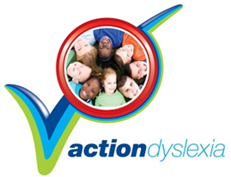

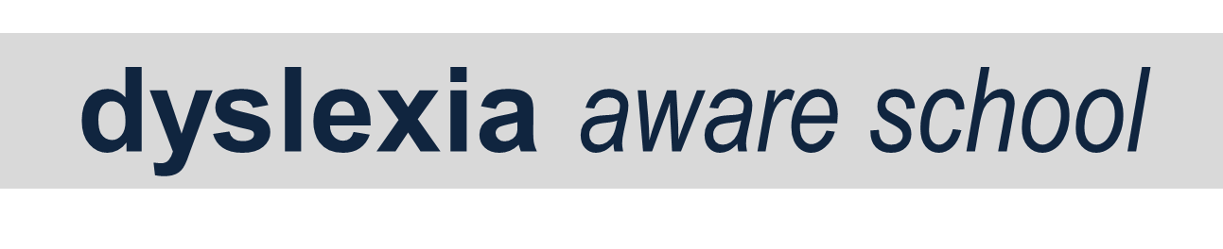
Email: standrewsramsbottom@bury.gov.uk Website: www.standrewsramsbottom.co.uk

